# Technical Paper

**CYBER SECURITY GAMING SYSTEM**

Isheanesu Vunganai, W Manjoro

Software engineering department , Harare Institute of Technology

*vunganaiisheanesu@gmail.com*

*w[manjoro@hit.ac.zw](mailto:manjoro@hit.ac.zw)*

School of Information sciences, Harare Institute of Technology, Zimbabwe

***Abstract -* Cyber Security Gaming System is a software system that allows a user to play educational game(s) about the cyberspace and at the same time act as a platform where users can submit a report of cyber-crime done to them or a colleague. It is also a system that spreads awareness of the cyberspace, cyber crime and cyber security through news and a calendar of future cyber security events.**

1. **INTRODUCTION**

Zimbabwe is a developing country that is still growing in terms of technology at a faster pace, but, the bigger the influence of technology, the bigger the Cyber Space, and the greater the Cyber Risk and Crime. Thus, the need for a Cyber Space Control measure. Cyber Security is an immediate online system that links cyber security reports to the authority that can help Zimbabwean people who are exposed to Cyber Crime but at the same time creating a fun learning experience for its users regardless of age. This platform allows people to air their Cyber Security ideas, experiences, and get education.

The goal of the project and main focused objectives of the Cyber Security system are;

To create two games that are fun and interesting in a way to educate Zimbabweans on the Cyberspace, its risks and securities. these games being:

* Quiz Game
* Cyber Chace

To have windows that promote awareness of the Cyber space, crime and security by:

* Showing recent news about the Cyberspace (Trending News)
* Showing recent and future Cyber Security events (Cyber Calender)

To provide a button to submit reports of cases of cyber-crimes to the Zimbabwe Republic Police.

The implementation of this gaming system will be expected to shine on what can be done to best educate and protect Zimbabweans from cyber risks that are thriving on the cyberspace and on their lack of knowledge. The Design and content of serious games affect learners’ potential to form knowledge, skills and Habitual patterns [1]. This system will be a way out for many Zimbabweans to be educated, protected and protect themselves on the cyberspace, as this system will work as a way for Zimbabweans to learn and at the same time have fun.

1. **LITERATURE REVIEW**

**Introduction**

In relationship with this project many researches were carried out earlier, and a web based and desktop applications have been made specially to cater for the use of serious games to educate people especially students and employees internationally. This has been successful but in the case of Zimbabwe, such practice has not been widely explored. Many incidents of cybercrime have been happening every day in Zimbabwe, with many victims fallen to the traps because of lack of knowledge and immediate support, this project is going reduce the consequences of those situations allowing effective cyber security education together with trendy news to keep citizens up to date with new tactics that cyber criminals are coming up with to fool them.

**COMPARING SERIOUS GAMES FOR CYBER SECURITY EDUCATION**

The paper on ‘Comparing Serious Games for Cyber Security Education” expressed the use of gaming as a way of education that can be used even for government institutions, big organizations and learning constitutions. It made a note of how cyber security games contributed to the spread of awareness in a more captivating way through gaming by comparing a set of games and their quality educational tactics. The concept of serious games for cyber security awareness initially was one part of a broader awareness campaign led by governments, corporations, cyber education organizations to teach basic information assurance concepts such as: confidentiality, authentication, integrity, and availability to informal learners (people with no prior knowledge or limited knowledge).[1]

**HOW TO ENHANCE CLASSROOM LEARNING. RETRIED**

The second research paper was the enhancement of classroom learning experiences using gaming and how it is a better way for learning as it demands more interaction with a user and at the same time teaching in a fun way. According to research, using games in teaching can help increase student participation, foster social and emotional learning, and motivate students to take risks. One study of the popular multiple-choice quiz game Kahoot found that it improved students' attitudes toward learning and boosted their academic scores [2]

**CYBER SECURITY STATISTICS – 2022 CYBER SECURITY CHALLENGES**

The research on the Cyber Security trends highlighted the growth and spread of malice on the Cyberspace has been contributed by the lack of awareness and poor practices by people globally .That is because organizations continue to lack cyber security awareness and utilize poor practices that result in their data being unprotected and vulnerable to theft and breaches[3]. Research also showed that with the lack of knowledge towards cyber security people have globally, there have been more attacks being reported, from the past years up until now from a smaller scale (individual) to greater scales (governments, organizations). The following are examples of attacks that have been recently reported on a global scale.

## CYBER SECURITY STATISTICS THE ULTIMATE LIST OF STATS DATA AND TRENDS FOR 2022

*‘2022 – The ZLoader botnet responsible for distributing the ZLoader malware was taken down in a joint effort with Microsoft, ESET, Black Lotus Labs, Palo Alto Networks, HealthISAC, and Financial Services-ISAC.*

*2022 – On May 8th, 2022 the national emergency was declared due to an ongoing Conti ransom ware attack against several Costa Rican government entities.*

*2021 – Saudi Aramco experienced a data breach exposing sensitive data on employees and technical specifications of the organization. Threat group ZeroX is demanding a payment of $50 million'[4]*

From the presented researches, Zimbabwe seems to be a great risk of cyber-attacks and a system like Cyber Security Gaming system, it would be an effective way forward to teach people on cyber security in an efficient way like mini serious games and at the same time giving them a platform that allows citizens to report cases of cybercrime they encounter.

1. **DESCRIPTION OF PROPOSED SYSTEM**

Cyber Security Gaming System is a desktop system which work on both offline and online the internet network services on any desktop platform e.g. desktop computer, Laptop etc. The user installs the Application and can traverse through the application. The application has two main regions where the user can access the data. These fields include the Dashboard and Game Arcade;

The Dashboard is the section responsible with the spreading of awareness and reporting cyber-crime; it has the news board, calendar and Report Form. This offers a great way to keep up to the new trends in Cyber Security, have an easier way to report a cyber-crime from the comfort of one’s own home and keep up with the cyber events on the cyber security-based calender.

The Game Arcade were there are two games, the Cyber Chace and the quiz game. The Cyber chace game is of a character who has to avoid cyberspace harzards while running, e.g a ‘black hat hacker’. The Quiz Game is about answering a series of questions with a chance of unlocking brand new avatars. Both games make the learning experience much easier and fun.

Once done with the application the user can easily exit the system.

**HARDWARE**

To implement the Cyber Security Gaming System a user will need a desktop computer or Laptop. The software will be hosted on a game server and from anywhere this software is downloadable via internet and accessible offline.

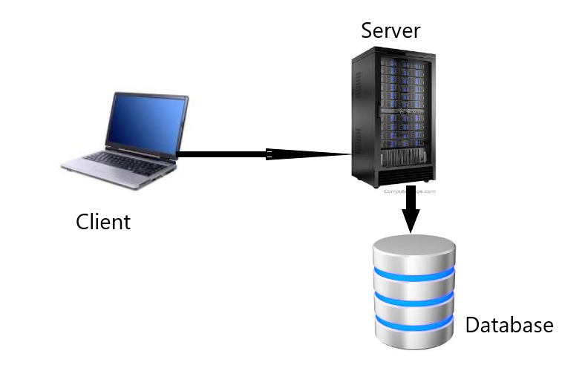

**NETWORKING**

The Cyber Security Gaming System is an offline-based system and consists of single-player games with game data stored in a database thus networking is not typically expected in the games to a database, as both games do not require communication between players or with a central server. This is best for handling offline play, since the player can gracefully return to an offline state when network connectivity is lost without any disturbance.

However, For the Dashboard, where there is the Report to be submitted, networking is required to send a document from the to another computer over the internet. File transfer would be used to copy or move the file from the user’s computer to the police email over the internet connection. To send the report, the user’s computer must be able to connect to the internet. The report would be transferred using the file transfer protocol, such as FTP or HTTP, or by sharing the file to any Windows application that supports services like OneDrive or Google Drive.

1. **RESULTS AND SUMMARY**

The system managed to meet its main objectives. As mentioned in the previous chapters, the system has two major parts; the Dashboard and the Game Arcade. The Dashboard is capable of giving the most recent news on cyber security and forward their report to their report to the police. The system also provides the user with a detailed cyber security based calender with events expected in each month. This meets the two objectives of spreading awareness to the public and creating a feature for people to report cyber crime directly to the police.

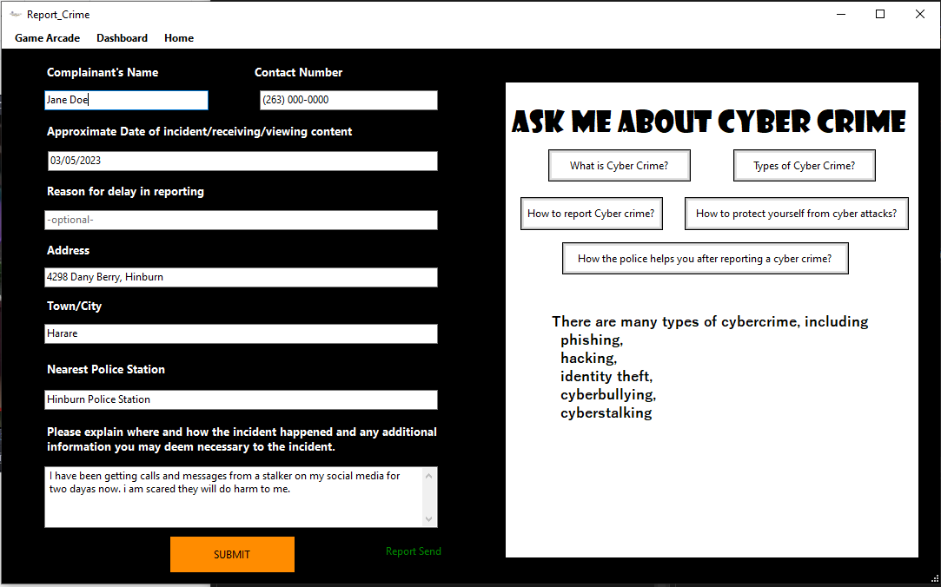Fig2. Report Window, Report Send

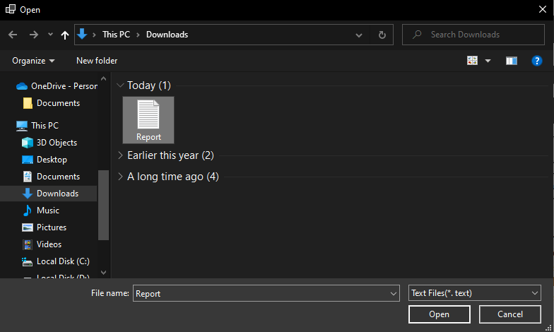

Fig 3. Report Received

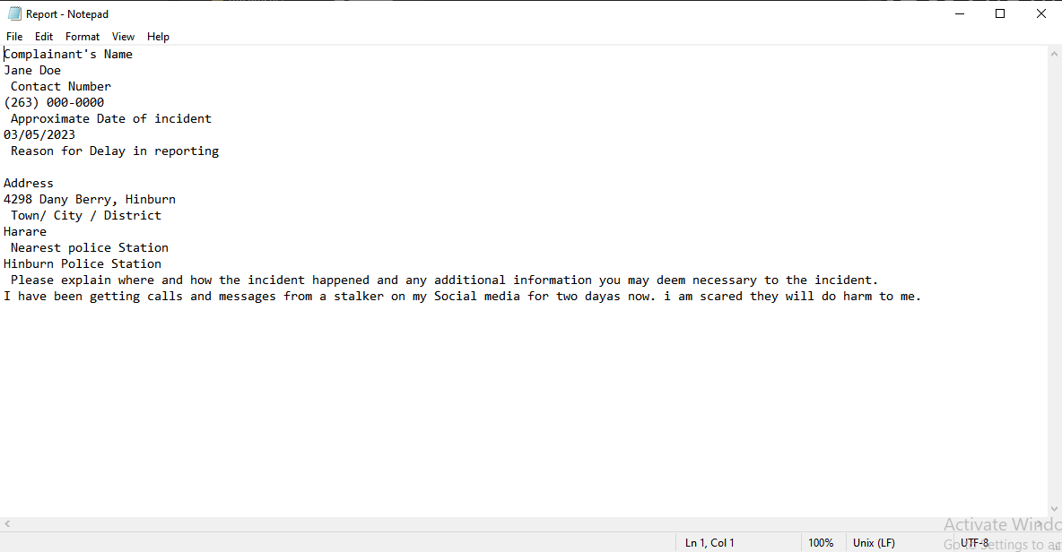

Fig 4. Report created

The Game Arcade fulfills the objective of using serious games to educate people on cyber security. The two games are meant to capture the interest of different ages of users, for instance, the quiz game that is more academically focused offers a chance to change avatars as a reward thus more appealing to the older users while the Cyber Chase of controlling a character to avoid obstacles would be more appealing to the younger users.

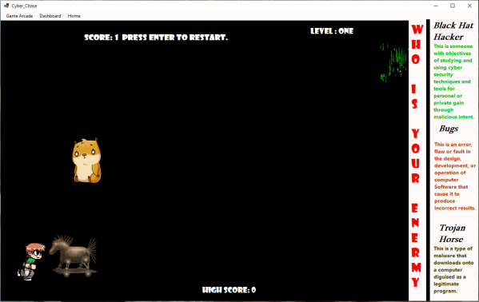

Fig5. Cyber Chase

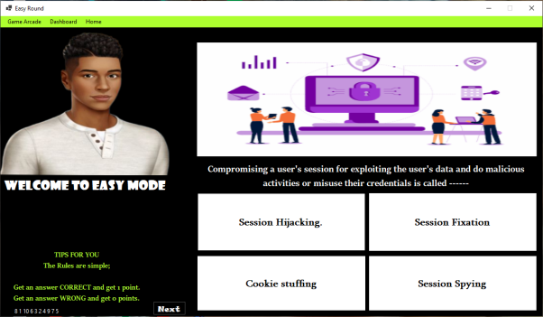

Fig 6. Quiz, Easy Round

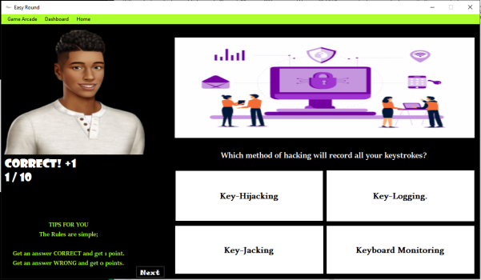

Fig 7. Easy Round - Correct

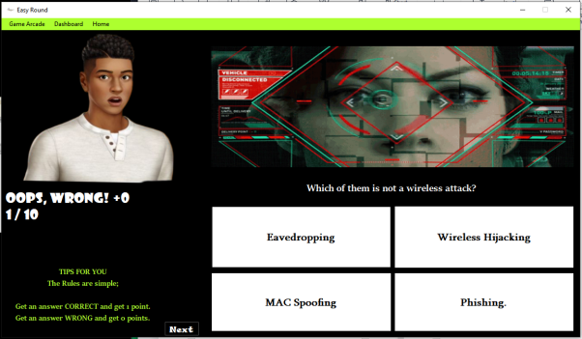

Fig 8. Easy Round - Wrong



Fig 9 Change Avatar

1. **CONCLUSION AND FUTURE WORK**

Since the user will be using the system for the very first time, the developer recommends that users be given detailed instructions page with list of instructions / user manual and a short demo video of how to navigate through this system. Since this system is for all ages, for the younger users and older generation users, It can be necessary to offer to a candidate the information before they initiate as well as the benefits of the system to the users. I recommend the use of user-friendly, clear interfaces as well as interactive interfaces. I also recommend the use of visually appealing interfaces as well as keeping the system up to date with modern technologies.

From the analysis of the proposed system and the prototype developed, I urge future researchers in the field of cyber security gaming system development to look at the following aspects so as to add to the work that has already been done:

1. Incorporating ways to detect cyber security break-in’s into the system

2. Add a feature for weapons in the cyber chase where user can shoot down the obstacle in its way

4. Use of chat board as a way for interactive interface for users to share experiences about cyber crime

**REFERENCES**

[1] Winston Hill, Mescifint Fanuel, Xiaohong Yuan, (2020), Comparing Serious Games For Cyber Security Education, Retrieved from www.sites.asee.org

[2] Edutopia Article (26 March 2021), How to Enhance Classroom Learning. Retried from www.edutopia.org

[3] Fortnet Article (2022),. Cyber Security Statistics – 2022 Cyber Security Challenges.Retrieved from www.fortnet.com

[4]Purplesec (2020), Cyber Security Statistics The ultimate List of Stats Data and Trends for 2022. Retrieved from www.purplesec.us